**IFT 466 Advanced Computer Networks**

**Lab 16  
BGP – iBGP Configuration (Oops)**

1. Setup up the following topology on Packet Tracer.  
     
   As you can both routers are in the same autonomous system.

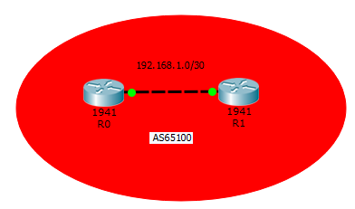

1. Now configure the routers with IP configuration details from the topology above.  
     
    ✓
2. Make sure you can ping between both routers.



✓

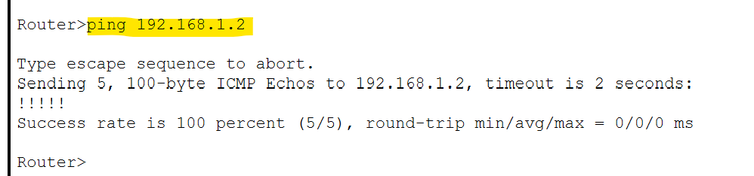

1. Now we have basic connectivity so we will now configure R0 the BGP protocol



**What error did you get when you entered those commands?  
%Cisco Packet Tracer does not support internal BGP in this version. Only external neighbors are supported.**

1. Based what we did in lab 14, I want to update the topology that you created in step 1 of this lab, but this time have the two routers in two separate autonomous domains.   
     
   Packet tracer does not currently support internal BGP. …..Oops!  
     
   Insert a screenshot of your updated topology below.

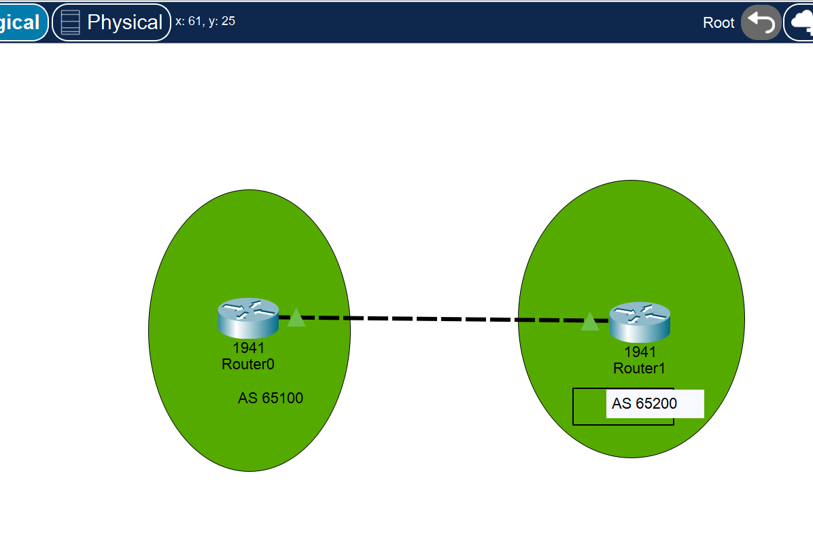

1. Logo

   Description automatically generated with low confidenceNow configure both routers with the same two commands that we used in step 4 but this time have the two routers in different AS’s.

✓

1. Insert a screenshot of both updated router configurations below (just show the two configuration commands that you entered in step 6 below.

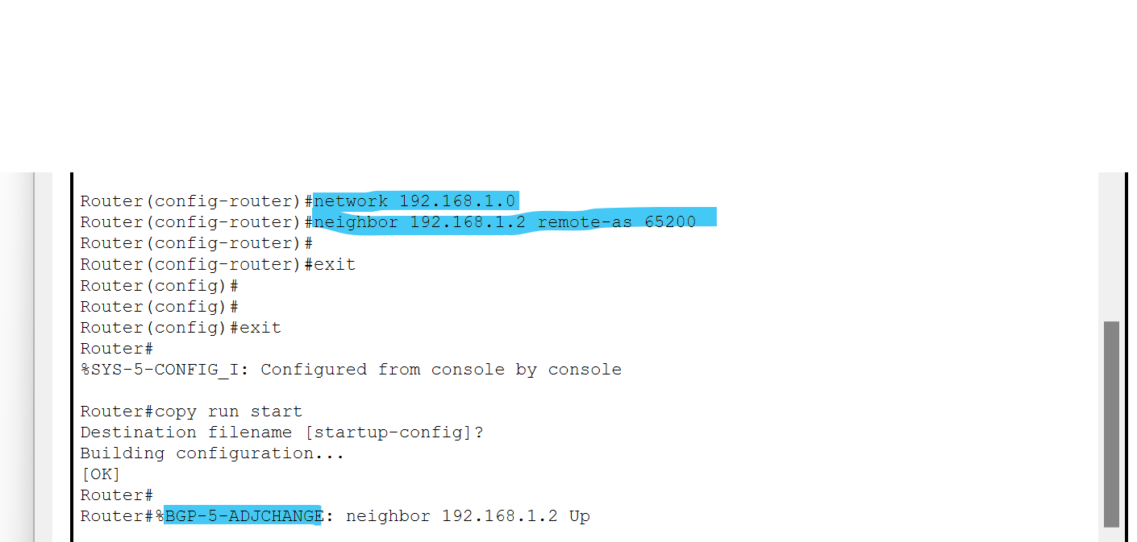

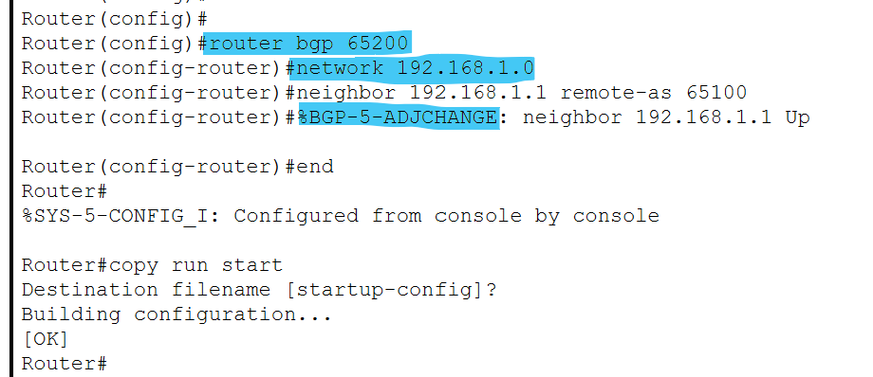

1. Insert a screenshot of the successful BGP adjacency change between both routers below.

